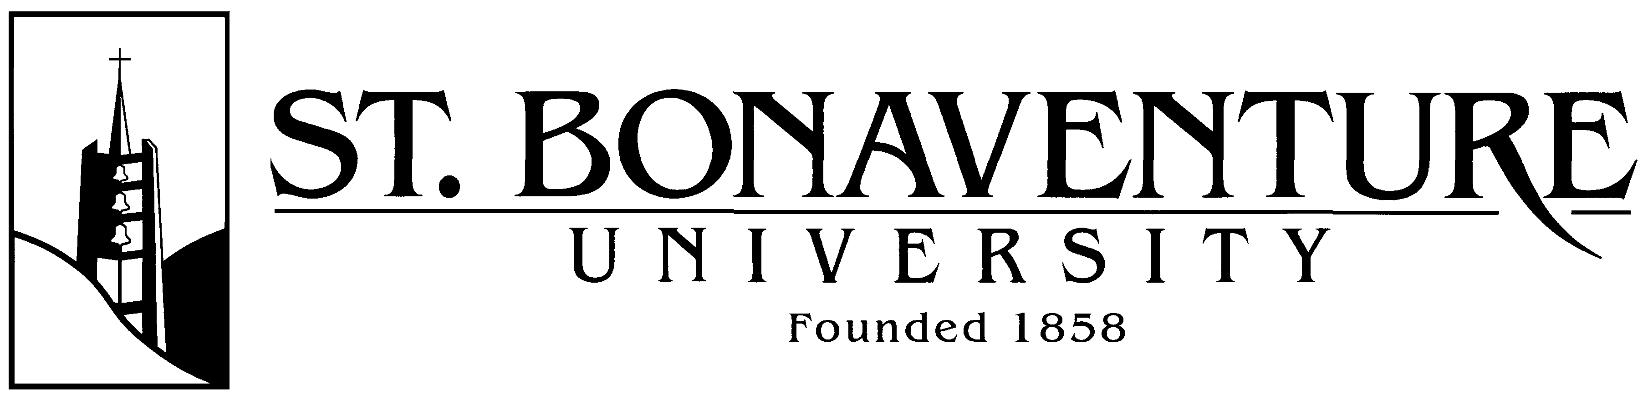
Dual Enrollment Frequently Asked Questions
1.What is dual enrollment?
A dual enrollment program is when a high school student takes college courses that count toward high school graduation as well as earning college credit. In this way, a high school graduate enters college at an advanced level (important for getting priority in signing up for courses) and fully prepared for the structure and rigor of a college education.
2. What makes this program so special?
Unlike most dual enrollment programs, where high school seniors take one or two courses per semester, this program is established specifically for high school students and will allow them to take three courses per semester. Our license does not allow a student to take more than 59 credits in this program. That means a high school student taking the full course load of 59 credits in this program graduates high school just shy of junior status in college, as 120 credits is equivalent to the total amount required for a college degree.
3. Who teaches the courses in this program? College professors from St. Bonaventure University (SBU) teach the courses. On occasion, adjunct professors from SBU are on the faculty.
4. What courses are being offered? The program of studies is in liberal arts: English composition 1 & 2, Public Speaking, Popular Literature, French 1 & 2, World History, American Politics, Law & Society, Biology, and a Math sequence of Pre-Calculus, Calculus 1, Calculus 2, and Statistics. Classes are offered based on enrollment.
5. Will these courses transfer to other colleges or universities? Of course, these courses transfer directly to the main campus of SBU, but they also will transfer to virtually any other college. It is impossible to make a definitive statement because each college has its own rules for accepting transfer credit and for residency requirements, but the courses are selected precisely to facilitate transfer. The decision to offer these classes away from the high school increases this likelihood even further because many colleges and universities accept dual enrollment credits only if offered at an actual college campus and taught by college professors.
The only college/university we found who would not accept dual enrollment credits was Notre Dame University. One Ivy League school (Penn) has accepted our credits, but others may not. If a student knows which college/university he/she wants to attend, he/she may easily inquire of the school directly. SBU administrator (Ms. Wilks) can facilitate that inquiry.
6. Where is the Center? How will I get there? The Dual Enrollment program is offered in the Pine Grove Ambulatory Surgery Center building. It is located roughly six miles north of downtown Warren on U.S. 62. It is located 8 to 10 miles south of Jamestown, Southwestern, Frewsburg, and Falconer High Schools. Classes begin at 8:45 am and end at 12:45 pm. If you have your driver’s license, you may drive yourself, or the program does pay (due to the generosity of community support) for Warren County School District buses to transport those students who need this service. This is at no cost to the students.
7. How much does it cost? For 2021-2022, no student pays more than $495 per credit hour, or $1,485 per 3-credit course. There are additional income-based scholarships available from the Community Foundation and the DeFrees Family Memorial Fund. Blair LLC and Whirley also offer scholarships for sons and daughters of their employees. Please see the document describing these scholarships.
8. How much does it save? Some students have saved the cost of almost two years of undergraduate studies. We have found that the students who were admitted to the program can save education TIME by being admitted to a college or university with earned credits. Students can earn a bachelor’s degree in as little as 2 years and some have earned a master’s degree in the time it would normally take to earn a bachelor’s degree. The cost of attending the dual enrollment program for a year or two is a BARGAIN!
9. What other advantages are there for SBU Dual Enrollment Students? Many of our former students report that they are far more prepared to be successful in college than their peers. They know how to study and how to prepare for their classes. They have experienced a challenging yet supportive atmosphere for the past two years. THEY HAVE EXPERIENCED COLLEGE!
10. What is a credit hour? Courses taken in college are measured in terms of credit hours. To earn one credit hour, a student must attend a class for one classroom hour (usually 50 minutes) per week for the whole semester (usually 16 weeks). Classes are offered in 1 - 3 credit hour increments, and sometimes larger amounts, but typically, courses are considered as 3 credit hours, meaning you’ll attend them for 3 hours a week.
11. What is the significance of class rank? Most studies indicate that class rank is not a valid measure of student achievement, given the unevenness in the rigor and grading scales of the nation’s schools. The majority of high schools have eliminated the use of class rank and rankings such as valedictorian. According to a recent report by the National Association for College Admission Counseling (NACAC), more than half of all high schools no longer report student rankings. “The most important reason that class rank is on the decline is because it really isn’t a direct measure of student achievement,” said David Hawkins, executive director of educational content and policy at the National Association of College Admissions Counselors. There is a mistaken belief that class rank equals college scholarships. Regardless of class rank, SBU students have attained a variety of scholarships at their chosen colleges/universities.

12. Will my credits transfer to the college I attend to count toward my required courses in my chosen major, or will my credits be classified as elective? Typical college degree programs include both required and elective courses. Students must earn a specified amount of credits, both required and elective, to graduate. Each college major has a set of program-specific required courses that all students must complete. In contrast, elective courses are up to “student choice” and allow students to develop a more focused major or to learn about something completely new and different.

The general experience has been that SBU DE credits transfer as the course was taken and counts as the required courses and not simply electives. For example, an English course taken at SBU DE counts as an entry level English requirement, not just an elective.

Here’s why this is important: as most underclassmen are fulfilling their first and second year requirements, and are the last in line to register for all courses, SBU DE students are able to register earlier and take advanced courses towards their majors from day one. Or they are able to pursue a double major in 4 years or obtain a master’s degree in 4 years. Or they might choose to study abroad for a semester and still graduate in 4 years. The bottom line is that SBU DE credits open up valuable opportunities that do not exist for the typical college freshman or sophomore. That being said, it’s up to each student to verify with his/her specific college whether the SBU Dual Enrollment credits will transfer as required credits or elective credits.

